**USDA-NIFA-OREI, Award Number: 2018-51300-28561 - “Bedding strategies that promote udder health and milk quality by fostering a beneficial microbiome on organic dairy farms.”**

Project update for scientific and industry advisors

The purpose of this meeting is to provide a summary of our progress on this project and to solicit input on our next steps. The meeting schedule follows the order of this report, and key questions and discussion points we hope to address during the meeting are in *blue italicized text.*

Executive summary

We are currently in year three of the three-year project with an intent to request a one-year, no-cost extension. No-cost extensions are automatic so the new end date for the project should be August 30, 2022. We have completed research objective 1a and a manuscript resulting from this work is currently in revision after a first round of reviews. Work on the remaining objectives was interrupted by the COVID-19 outbreak. We are about 50% complete with the original cross-sectional survey of organic farms. We completed a longitudinal study of 10 farms, 5 using tiestall facilities and 5 using bedded packs. We have selected samples from the longitudinal study for marker gene (bacterial 16S and fungal ITS) metagenomic experiments. We have initiated functional assays for bacterial and fungal isolates from the herds enrolled in the longitudinal study. We are preparing for shotgun metagenomic studies using samples from the longitudinal study.

We have revised our outreach activity plans, as the previously planned activities of on-farm demonstrations and peer-to-peer meetings are not plausible given the COVID-19 outbreak.

**Contents**

Page

1 Cover and executive summary

2 Meeting schedule

3 General summary

Research progress

6 Objective 1a – Industry survey

7 Objective 1b – cross-sectional survey of practices and point in time observations

8 Objective 1c – cross-sectional survey of costs and perceived benefits/opportunities

8 Objective 2a

10 Objective 2b

14 Objective 3a

16 Objective 3b

17 Extension and Outreach progress

Figures

3 Figure 1: General overview of original research objectives

6 Figure 2: Number of farms within each housing strategy stratified by type of bedding

material used.

10 Figure 3: Plot of quarter milk Linear Score (Log Somatic cell count) by pathogen isolated

from the quarter.

13 Figure 4: Study design for project objective 2b - Sequencing of marker genes for

bedding, milk and teat skin microbiome.

14 Figure 5: Bacterial Simultaneous antagonism assays to identify inhibitors of

mastitis pathogens.

15 Figure 6: Fungal Organisms associated with oxidative enzyme activity and

found in the udder

16 Figure 7: Carbon utilization of 28 *Penicillium* and *Aspergillus* isolates from 2 bedded pack

and 1 tiestall environments.

Tables

4-5 Table 1: Summary of accomplishments and plan of work for continuity

9 Table 2: Presumptive species identification of isolates saved from the 10-herd

longitudinal field study

12 Table 3: Number of quarters meeting the infection status definitions included in the

source data files for sample selection for the marker gene metagenomic experiments

Meeting schedule:

Day 1 – January 19, 2021

We will focus on research progress during this session, and cover outreach and extension activities if time allows.

2:00 pm Introductions

2:10 Review of agenda and plan for meeting

2:20 Objective 1a - Short Industry survey of organic farms in Vermont

2:25 Objective 1b – 40 herd cross sectional study - interview survey and sample collection

2:40 Objective 2a – 10 herd longitudinal study – mastitis epidemiology

2:50 Objective 2b – 10 herd longitudinal study – marker gene sequencing

3:05 Objective 3a – functional assays and endogenous inhibitors

3:20 Objective 3b – shotgun metagenomics

3:30 Adjourn – continue discussions next week or schedule additional meetings

Day2 – January 25, 2021

12 noon Introductions

12:05 Objective 1c – Economic survey – 40 herd

12:15 Outreach and extension – brief review of original plan for activities and update

1:00 Adjourn – continue discussions by scheduling additional meetings

General Summary

There were three major research objectives proposed in the original grant application; each of these have specific objectives (figure 1 and table 1). There were four general extension and outreach objectives proposed in the original grant application (table 1).

Table 1 provides a brief status update for each objective. More detail on the status of each objective and specific questions or possible discussion points are provided in the text sections for each objective/or specific aim.

COVID-19 disrupted our progress during year 2 and impacts modifications to the objectives are described.

Figure 1: General overview of original research objectives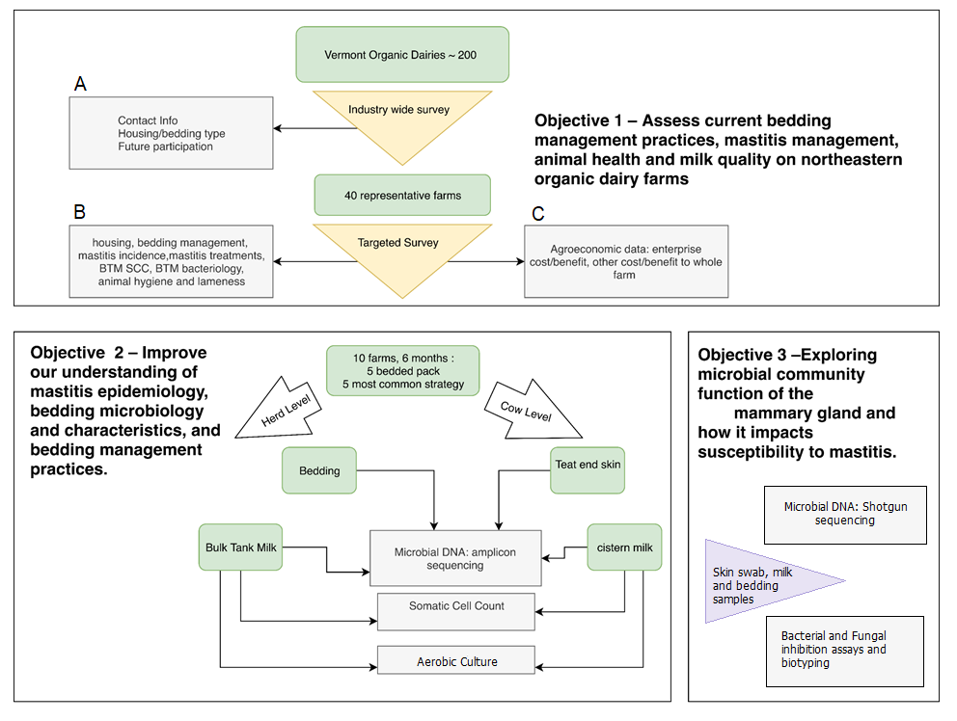

**Table 1: Summary of accomplishments and plan of work for continuity to meet original objectives or revised objectives**

|  |  |  |
| --- | --- | --- |
| **Original Objectives** | **Accomplished** | **Status and Revised Objectives Proposed** |
| **Research** | | |
| **Research Objective 1 - Industry Surveys** | | |
| 1. Survey of all organic dairy farms in Vermont | Completed survey of organic dairy farms in Vermont in year 1 – a manuscript describing findings was submitted in October 2020 | None - complete |
| 1. Observational study of 40 organic dairy herds – cross-sectional survey (interview and sample collection, single point in time) | 21 herds enrolled and sampling completed – thus approximately 50% of this objective was completed in year 1 | No change in objectives – completion of survey delayed by COVID shutdown in year 2; current goal is to survey 19 additional herds in winter of year 3  Analysis and reporting of results delayed until years 3 and 4 |
| 1. Economic Survey - cross-sectional survey (interview) | Goal – same 40 herds as in b. above; X herds completed – interview survey of economic parameters and qualitative outcomes related to costs and benefits of current bedding system | No change in objectives – start of survey delayed by COVID shutdown in year 2 – survey begun in year 3 |
| **Research Objective 2 – observational studies and metagenomics of the mammary microbiome related to bedding practices** | | |
| 1. Observational study (longitudinal cohort) of bedding management and mastitis risk compared for herds house in tiestall barns and on bedded packs | 10 herds enrolled in study in year 2 (December 2019 to March 2020) – 8 of 10 herds were sampled for 3 monthly intervals, one herd was sampled 4 times, and one herd sampled twice before COVID shut-down. The original plan was to sample all herds for 6 months. | No change in hypothesis being tested - Sample and data analysis was initiated using the data acquired from the completed visits and it was determined that the scope of sampling is likely adequate to test the original proposed hypotheses – only minor changes in scope of work; revision in scope of study in that only 3 visits per herd were completed for most herds |
| 1. Sequencing of marker genes for milk and bedding at herd level and of milk and teat skin for four udder health categories at cow level. | Sample processing was delayed approximately 6 months due to the shut-down but has started | No change in plan of work – work was delayed until year 3 and will extend into year 4 |
| **Research Objective 3 – functional mechanisms of microbial communities related to udder health resilience and mammary dysbiosis** | | |
| 1. Simultaneous antagonism assays | These assays have been begun and will continue in year 3 as originally planned | No change in plan of work – work has been started in year 3 as planned and will extend into year 4 |
| 1. Shotgun metagenomics | These assays are delayed; they will begin in the last quarter of year three and continue into year 4 | This work is delayed approximately 9 months and the majority of this work will be accomplished in year 4 |
|  |  |  |
| **Original Objectives** | **Accomplished** | **Status and Revised Objectives Proposed** |
| **Extension and Outreach** | | |
| 1. Specific Outreach activities | | |
| 1. Conferences – presentations and workshops at farmer and industry conferences | We participated in one conference in year 1 promoting the work and farmer engagement in our surveys and observational studies | Farmer conferences in year 2 were cancelled due to COVID restrictions  Farmer conferences in years 3 and 4 may be virtual. We will develop web-based virtual content for producer education.  Target venues:   * Vermont Grass Farmers * Northeast Pasture Consortium - Webinar and discussion presentations series – partnering with other NE groups * Organic Dairy Farmers conference   We are exploring presenting a session for the Pasture Consortium for 2022 – relevant to audience and never before been discussed- how bedding management issues support animal health and also integrate into soil management and quality |
| 1. Newsletters | Will be pursued as planned | None – work on-going |
| 1. On-farm events; peer-to-peer on-farm meetings | On-farm events for year 2 were not pursued due to COVID restrictions | These events will not be pursued as originally planned, rather we are working to develop virtual web-based media content to communicate information developed from our research efforts. |
| 1. Extension bulletins – develop revised guidelines and web-based resources including economic assessment of bedding management practices | Development of Guidelines is underway in year 3 and was delayed by approximately 9 months. | Delays in data collection in year 2 has resulted in a change in the timeline for this objective and this work will be conducted in years 3 and 4 |

Research Progress Summary and Discussion Points

**Objective 1a – Industry Survey**

We completed a descriptive observational survey to quantify the frequency and diversity of winter housing and bedding types used by organic dairy farmers in Vermont. Beginning in December 2018, a short questionnaire was administered by web, mail, and telephone to a source population defined as all producers of organic dairy cow milk in Vermont (n = 177) listed in the United States Department of Agriculture Organic Integrity database. Our approach yielded an 82% (n = 145) response rate from certified organic farms producing cow’s milk in Vermont at the time of the survey.

The three most common housing and bedding material combinations used by respondents were tiestall housing with wood (sawdust or shavings) bedding materials (45%), freestall housing with wood bedding materials (14%), and freestall housing with sand bedding (12%) (figure 2). Fifteen percent of respondents reported using more than one type of facility for winter housing of lactating cattle. The median number of lactating cows on farms among respondents was 59.5 (range 2 to 400), and the odds of using more than one type of facility to house lactating cows increased positively with the number of lactating cows reported for a herd. Four primary categories of cattle breeds were identified among the respondents’ herds: 1) Holstein cattle only; 2) Jersey cattle only; 3) mixed Holstein and Jersey herds with crosses; and, 4) mixed Jersey and Holstein herds with one or more additional breeds. Breed distribution was similar across the housing and bedding type categories. An association between frequency of individual cow milk somatic cell count testing and housing type was identified; respondents using freestall sand facilities tested less frequently than herds in tiestalls with wood bedding. While the questionnaire length limited the amount of information gathered, the response proportion was exceptional and overall our survey results provide valuable insight on Vermont organic dairy housing and bedding practices that should inform future extension and outreach efforts for this sector of the dairy industry.

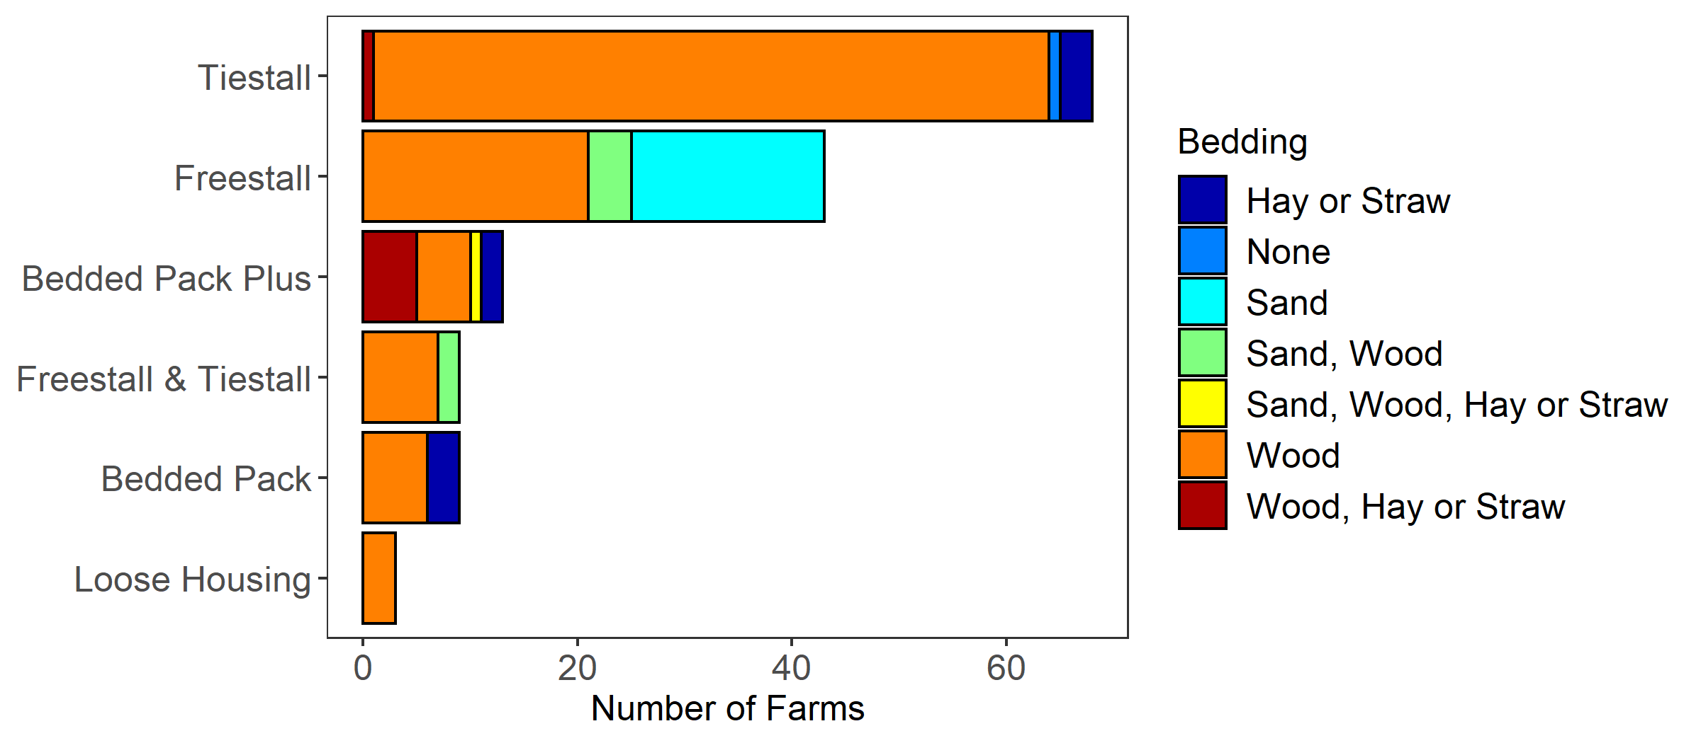

**Figure 2**: Number of farms within each housing strategy stratified by type of bedding material used. Producers that reported using a bedded pack barn in combination with another housing type are grouped together (“Bedded Pack Plus”).

**Outcomes**: A manuscript describing the process and results of this survey is under review (in first revision) for publication in Journal of Dairy Science. The results provide a data set that we used to identify farms for the subsequent studies.

**Discussion points**: We have learned about the frequency of types of housing in the state and were particularly surprised by the number of herds (15%) using more than one type of facility and bedding material for lactating cows. We hypothesize these multi-housing type farms are in or have been in some transition that creates a need for multiple housing types, e.g. growing herd size or transition from an older facility to a new facility type. Based on our review of the literature and our results of this survey, we see a number of opportunities for research on future needs and trends related to housing organic dairy cattle, particularly related to animal well-being and consumer perception of dairy production systems.

**Objective 1b – Cross-sectional survey – “40-herd study” – management practices and outcomes**

In Winter 2019, we initiated this study and were able to complete interviews and sample collection on 21 farms, including:

10 tiestall herds bedding with wood products,

5 freestall herds bedding with wood products,

1 freestall herd bedding with sand,

5 herds using bedded packs.

The questionnaire is a 30 page (about 100 questions) instrument that requires about 1 hour to administer. The questions are a mix of multiple choice response and open questions. We obtain audio recordings in addition to written notes from the interviews. The questionnaire addresses topics including mastitis control practices, clinical mastitis recognition, milking procedures, dry cow mastitis control, dietary issues related to supplementation, housing systems, bedding management practices, general demographic herd information and perception of mastitis incidence and prevalence. The questionnaire design was guided by our review of instruments previously used in surveys by Pamela Ruegg and others (Organic C.O.W. study) and Sandra Godden and others (U Minnesota national bedding practices study).

Samples collected from the farms include: Bulk tank milk sample, used and unused bedding samples, and observations on facility ventilation, stall size and design (where applicable), barn design and size (data allowing estimation of stocking density or area per cow), and information on outdoor turn-out for winter housing. The bulk tank milk and bedding samples are submitted for aerobic culture and are available for metagenomic studies.

The overall objective will be to explore potential associations between milk culture and bedding culture outcomes and the type of facilities. We will use the survey response data to explore variation in farmer-reported management practices that might influence these outcomes, and to characterize the frequency of mastitis control practices on these farms.

**Outcomes**: We have completed interviews and sample collection from 21 herds, but these are “unbalanced” with regard to the frequency of common facilities and bedding types used. We had hoped to complete the remaining 19 herds in Winter 2020. We may be challenged to identify 10 bedded pack herds to reach our target of 10 herds in this category, ditto, perhaps freestall herds with sand in the target herd size range that test with DHIA monthly.

We have also observed that the bedded pack category is perhaps the most variable of the 4 “most common” housing and bedding systems.

1. There appear to be few farms using active composting bedded packs; most farms using loose housing with a bedded pack are maintaining static systems with or without some method of aeration.
2. A number of farms are using bedded packs in combination with another housing system; for example, they may have increased herd size when they constructed a hoop-barn structure for their bedded pack and rotate cows between the bedded pack and their tiestall facility.
3. The type of bedding material used in bedded pack facilities appears to be more variable than in other types of facilities.

**Discussion points**:

* *How best to complete the remainder of the 40-herd survey? Plow forward as planned (taking note of the year difference)? Stop now and analyze the data (sand freestall n of 1, so drop this group?)*
* *How to handle the apparent variation in bedding material and practices among the bedded pack herds?*

**Objective 1c – Cross-sectional survey – “40-herd study” - Economics**

Following on the above management practices survey, our intent was to also complete a separate survey of bedding and facilities costs on the same farms. This was originally considered an important component to informing our outreach objectives, and specifically to generate data to inform updates to bedding and facilities decision-making tools for farmers. Sarah Flack and Brian Jerose are currently conducting virtual interviews of the participating farmers. Questions in this interview dive deeper into bedding and facilities management by exploring costs and possible economic benefits of the systems. The questions ask for farmer reported financial estimates on factors related to materials costs, equipment costs, facilities costs, as well as observed or perceived benefits and challenges with their bedding systems, including any recent changes and their experiences.

**Objective 2a - Observational study (longitudinal cohort) of bedding management and mastitis risk compared for herds house in tiestall barns and on bedded packs.**

We planned to complete a longitudinal study comparing mastitis incidence and prevalence on 5 herds using bedding pack housing to 5 herds using the most common other housing system (presumably tiestall herds). From the survey data, we confirmed tiestall herds was a reasonable comparator group. The original plan was to follow these herds for 6 months using monthly quarter milk sampling and bacteriological culture from 35 cows per herd, plus collecting teat skin swabs from all quarters of the 35 lactating cows, and bedding samples. Samples collected under this design would be available for traditional aerobic culture-based mastitis surveillance as well as for processing for marker gene (16S) metagenomic analysis.

We enrolled 5 bedded pack herds and 5 tiestall herds and began sample collection in December 2019. We were forced to stop farm visits in March 2019, and completed 3 farm visits on 8 herds, 4 visits on 1 herd, and 2 visits on 1 herd (this last herd milks cows seasonally, and all cows were dried off in January).

We have collected 4,212 quarter milk samples (in duplicates) and teat skin swab samples from 1,536 quarters of 384 cows from the ten herds. We completed individual aerobic culture of the duplicate milk samples, then pooled each of the duplicate the samples for measurement of quarter milk SCC, and saved aliquots of the pooled milk for subsequent use in amplicon and shotgun sequencing studies. Teat swab samples were vortexed and three aliquots of the suspensions saved frozen within 24 hours of collection, with two aliquots processed with propidium monoazide (PMA) prior to storage. We also collected cow level data on udder hygiene scores (2 parallel observers), and DHIA records data from each month we sampled the herds. Milk samples were not processed with PMA.

Milk sample aerobic culture results (saved isolates) – For the purpose of saving bacterial isolates found on culture, an intramammary infection (IMI) was defined as finding one or more colonies of the same morphological appearance on both duplicate milk samples collected on the same date. We recorded colony forming unit (CFU) counts for each observed organism that grew in culture. Occasionally, where there was heavy growth of an organism from only one of the two duplicate samples or *S. aureus* observed in a single sample, we saved additional isolates. Overall, we saved 1329 isolates with presumptive species identification based on morphological and basic biochemical characteristics, of which 1181 are associated with an IMI using definitions accepted in peer-review literature (Table 2). Species identification is being confirmed using matrix assisted laser desorption ionization-time of flight mass spectrometry (MALDI-TOF MS). Because bedding (“the environment”) is a common source of IMI caused by the “environmental Streptococci” (i.e. *Streptococcus*-like organisms) we are interested in these “major” mastitis pathogens in the context of comparing the two housing systems. Characterizing the *S. aureus* IMI in these herds is valuable because it provides an “outgroup” of a major mastitis pathogen where the source of new IMI is most likely other infected cows for comparison. While the potential environmental sources of the non-aureus Staphylococci are poorly understood, as expected they are the genus associated with the majority of intramammary infections. We are interested in exploring the non-aureus *Staphylococcus* species diversity on these farms, and the relationship between IMI, teat skin colonization and the observed quarter SCC. Preliminary analysis of the variation in SCC among quarters with IMI is shown in figure 3.

Add paragraph about how bedding samples were processed…. (TUCKER) .. mixing, PMA.. non-PMA chosen for amplicon sequencing based on preliminary experiment (see box plot)



**Outcomes**:

We are exploring these data to address the following hypotheses or questions.

1. Is there a difference in incidence and prevalence of species specific IMI associate with housing type? We plan to address this using logistic regression models including multiple predictor variables to explore factors influencing mastitis risk on these farms.
2. Is there a difference in degree of inflammation (SCC level) among IMI caused by different species in these herds?
3. How do potential diagnostic error and alternative IMI definitions influence our conclusions and how does the resulting sample size due to the truncated study influence the confidence in our conclusions?

**Discussion points**:

* *We decided not to extend the sampling of these herds into another year.* 
  + *Budgetary and time constraints prevent us from continuing the longitudinal study.*
  + *Preliminary analysis of the data suggest we have collected sufficient samples to use for objective 2b.*
  + *This decision will likely reduce the power of the study for identify differences between the 2 housing types, risking Type 2 error (cannot reject the null hypothesis of no difference) in incidence or prevalence due to housing types.*
* *We welcome comments and feedback on this decision and factors to consider as we proceed with the analysis.*



**Figure 3**: Plot of quarter milk Linear Score (Log Somatic cell count) by pathogen isolated

from the quarter. CNS = coagulase negative staphylococci, Negative = no organism isolated

from the quarter. The red dashed line is a linear score of 4.0 (SCC = 200,000 cells per ml).

**Objective 2b - Sequencing of marker genes for milk and bedding at herd level and of milk and teat skin for four udder health categories at cow level.**

The original grant proposal suggested exploring the milk and teat skin microbiome of mammary quarters in each of four udder health categories.

We originally proposed three related questions:

1) Does the quarter milk microbiome differ by bedding type and health category?

2) Does the teat skin microbiome differ by bedding type and health category?

3) How does the teat microbiome compare to the milk microbiome within bedding type?

We originally proposed to use quarter milk somatic cell count (SCC) and aerobic culture results from the longitudinal study to define four classes of udder health at the individual quarter level:

(1) “always healthy” or “never infected” (SCC is < 200,000 cells/ml for each sample time + no pathogen),

(2) “became infected” (SCC is < 200,000 cells/ml before increasing to ≥ 200,000 cells/ml + pathogen),

(3) “became infected and recovered” (SCC returns to < 200,000 cells/ml + no pathogen after increasing to ≥ 200,000 cells/ml + pathogen), and

(4) “always infected” (SCC ≥ 200,000 cells/ml + pathogen identified for each sample time).

We proposed a stratified random subsample of *N*=300 quarters from each bedding strategy would be submitted for marker gene (bacterial 16S and fungal ITS) sequencing (10 samples per health category x 4 categories x 6 months, plus 2 sampling and processing negative control samples per month).

We determined the truncated sampling completed December 2019 to March 2020 provided sufficient samples to meet the original objectives. We partially based our decision not to extend the longitudinal study into another year when we determined that we have sufficient samples within the four health categories. Figure 4 represents an updated flow chart of the study design for the marker gene metagenomics studies of our longitudinal study of mastitis incidence and prevalence on organic dairy herds using either tiestall facilities with wood bedding or bedded pack facilities.

We revised the original propose sampling scheme as follows:

1. Four specific aims (hypotheses) will be addressed using the available samples. We consider these as 4 separate amplicon sequencing experiments (Figure 4).
2. Do the teat skin and milk microbiomes of infected quarters differ from healthy quarters?
3. Do differences in teat skin and milk microbiomes of quarters sampled from cows housed on bedded packs differ from cows housed on wood bedding in tiestall facilities, account for infection status?
4. Do the milk and skin microbiomes differ within quarters that change their health categories over time?
5. Do the bedding and bulk tank milk microbiomes differ for farms using bedded pack systems compared to farms using tiestall systems ?
6. The definitions used to define the infection status of quarters for selecting samples will not restrict on SCC. But we will account for SCC in the analysis as a covariable.

(1) “always healthy” or “never infected” or “NNN” = no pathogen isolated from quarter at any time point;

(2) “became infected” “NYY” = no pathogen isolated at first month, followed by same presumptive pathogen isolated at second and third months;

(3) “became infected and recovered” “NYN” = no pathogen isolated at first month, followed a pathogen isolated at second visit and then no pathogen isolated at the third visit; and,

(4) “always infected” “YYY” = same presumptive pathogen identified at each time point.

1. We will remove observations associated with infections caused by uncommon organisms or groups of organisms that were rarely observed (Table 2) and limit the data set to include infection events associated with Coagulase-negative staphylococci, *Streptococcus*-like organisms, *Staphylococcus aureus*, and *Corynebacterium* species. The source data for these experiments is shown in table 3.



For experiments 1 and 2, we selected samples from the always infected and never infected (always healthy) quarters. We selected a total of 320 samples from 160 quarter observations (1 milk and 1 teat skin swab per quarter). Among these quarters, 80 are defined as always infected and 80 as always healthy, with 40 quarter observations from bedded pack and 40 from tiestall herds within each health category. We randomly selected two visits per herd to include in the source data sets so that we did not over select samples from the herd with 4 visits, or under select samples from the herd with 2 visits.

For experiment 3, we will enroll 10 quarters in each of the four health categories and explore the potential temporal changes in the microbiome over the 3 months of samples collection. For the transitional health categories (NYN and NYY) we have 66 NYN and 92 NYY samples, respectively, representing repeated sampling in just over 10 quarters in each category. We will randomly select 10 always infected and never infected quarters from the pool of samples selected for experiments 1 and 2 above, so that we will use the samples from experiments 1 and 2 in experiment 3.

For experiment 4, we have 30 bulk tank milk and 37 used bedding samples available. tiestalltiestallThe 4 additional samples are related to the farm we sampled a fourth time, which also moves their cows between bedded pack and tiestall. This highlights a limitation with our study, there is variation among the bedded pack herds in the type of bedding material and how cows are managed in these facilities. This also provides repeated observations of two types of bedding material used on the same farm.

For the four experiments we will submit 685 samples for 16S and ITS metagenomic sequencing at the end of January 2021. This includes 20 blank DNA extraction/processing control samples.

**Discussion points**:

* *We appreciate any comments on issues or pitfalls we have missed with this sample selection scheme.*

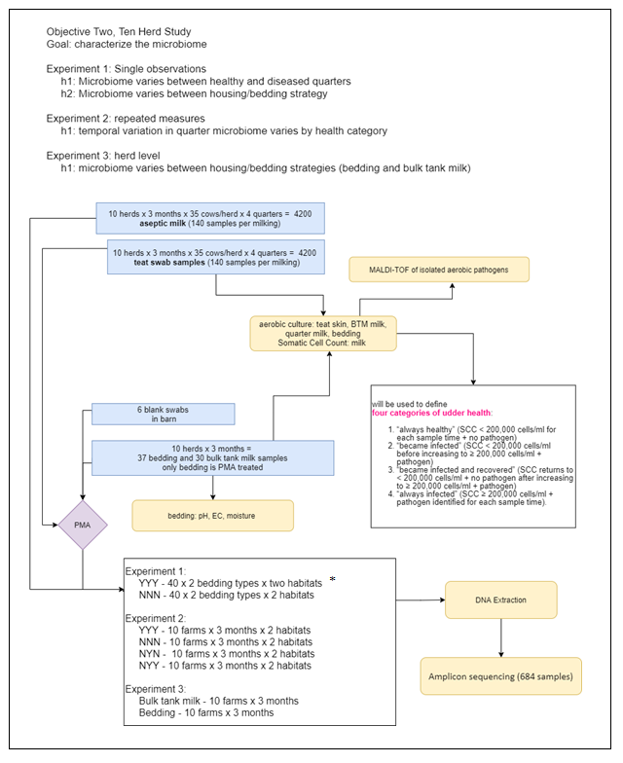

**Figure 4**: Study design for project objective 2b - Sequencing of marker genes for bedding, milk and teat skin microbiome. *Milk and teat skin samples for four udder health categories at quarter level, YYY = “always infected”, NNN = “always healthy”, NYN = “became infected and recovered” (i.e., new transient infection), and NYY = “became infected” (i.e., new infection that did not recover within 1 month).

**Objective 3 – functional mechanisms of microbial communities related to udder health resilience and mammary dysbiosis**

These experiments were not well detailed in the original proposal. Here we provide some additional detail. Paralleling the marker gene studies under objectives 2b, we will explore the possible functions of bacterial and fungal organisms in these experiments. We have sufficient samples to conduct these experiments on the sample samples used under objective 2b, thus extending the marker gene experiments with both targeted culture-based experiments to isolate specific bacterial and fungal organisms, as well as extending the market gene experiments using shotgun metagenomic approaches.

**Objective 3a. Functional assays - Simultaneous antagonism assays**

**Bacterial endogenous inhibitors of mastitis pathogens**. We will undertake 2 parallel experiments with the goal of identifying bacterial isolates that that are producers of antibacterial compounds. First, we will screen teat skin swab, milk and bedding samples for the presence of bacterial organisms with antibacterial activity that inhibits the growth of *Staphylococcus aureus*. We have adapted a simultaneous antagonism assay method that allows us to isolate and quantify the number of bacterial inhibitors from our samples. In a pilot experiment, using non-selective growth medium under aerobic conditions, we identified more than 130 *Bacillus* and *Paenebacillus* spp. isolates from milk and teat skin swabs of lactating cattle (figure 5A). Future work will include adapting these methods using Staphylococcus-selective culture methods to explore the prevalence and diversity of Staphylococcus species isolates with inhibitory activity.

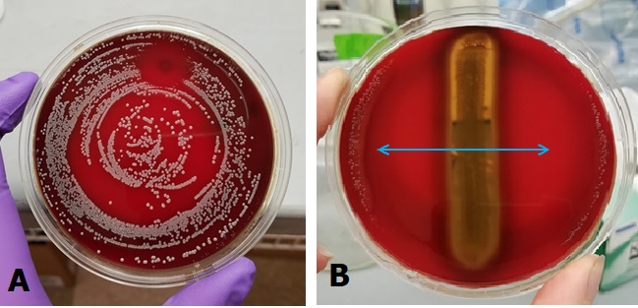

Figure 5: Bacterial Simultaneous antagonism assays to identify inhibitors of mastitis

pathogens. **A.** A teat swab sample suspension was plated on one side of an agar plate,

incubated for 24 hours, then the agar was flipped and a suspension of *Staphylococcus*

*aureus* was plated on the reverse side. The plate was incubated for 24 hours and examined

for zones of inhibition in the *S. aureus* lawn. Inhibitor isolates from the suspension are then

collected and saved for identification and further characterization. **B.** A single isolate in

pure culture is streaked down the center of an agar plate, the plate is incubated for 24 hours,

then flipped and a lawn of S. aureus is plated on the reverse side. The plate is incubated for 24 hours and the extent of growth inhibition of the *S. aureus* lawn is measured. In this picture there is a large zone of inhibition of *S. aureus* growth (blue arrows)

Second, we will screen individual isolates collected from milk and teat swab samples for their antibacterial activity (figure 5B). We have initiated experiments testing *Corynebacterium* species isolates for antibacterial activity against *S. aureus*. The methods are established and an undergraduate student has initiated these experiments.

**Fungal endogenous inhibitors of mastitis pathogens.** Asa Hurd and Tom Weicht have worked to develop selective culture methods for fungal genera and species of interest. We used data from our previous research (Andrews et al. 2019) to identify target fungal species. In these experiments, we will apply methods from plant biology and microbial ecology to identify the ecological characteristics of fungal organisms in the family Trichomaceae, and in particular the *Penicillium* and *Aspergillus* genera.

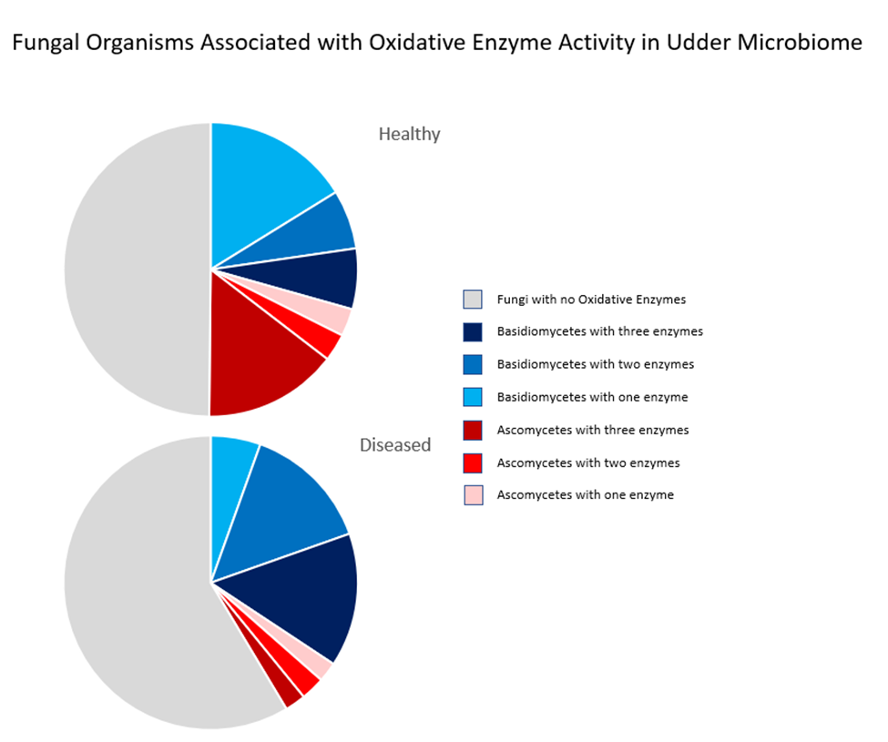

**Figure 6: Fungal organisms associated with oxidative enzyme activity and found in the udder.** Fungal organisms in the udder microbiome were classified based on their ability to produce Laccase Cu II, Phenoloxidase Mn III, and Peroxidase Fe III. Fungi were divided to Basidiomycetes and Ascomycetes and whether they could utilize only one, two, or all three of these enzymes. Diseased milk samples had a larger composition by OTU of fungi which could not utilize any of the three enzymes compared to healthy milk simples. Ascomycetes which could utilize all three enzymes were found in much greater proportion in healthy milk. Basidiomycetes that could utilize only one of the enzymes were found in higher proportion in healthy milk. Basidiomycetes that could utilize all three enzymes were found in higher proportion in infected milk.

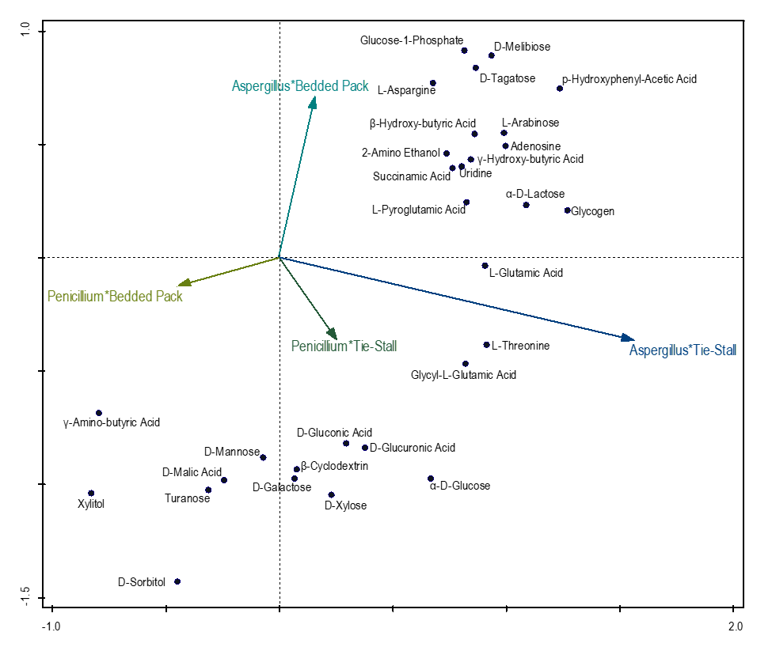

**Figure 7:** Carbon utilization of 28 *Penicillium* and *Aspergillus* isolates from 2 bedded pack and 1 tiestall environments. Displaying 30 best fitting carbon sources of the total 95. *Penicillium* isolated from bedded pack are most dissimilar in carbon utilization from the other 3 vectors and have an inverse correlation with both *Aspergillus* groups. However, both tiestall vectors show a close correlation in carbon utilization. *Penicillium* isolated from both bedded pack and tiestall share an affinity for utilizing D-sorbitol. *Penicillium* isolated from bedded pack are most dissimilar from the other three groups in their ability to metabolize γ-amino-butyric acid. *Aspergillus* and *Penicillium* isolated from tiestall shared an affinity for utilizing L-threonine and glycyl-L-glutamic acid.

**Objective 3b. Functional assays - Shotgun metagenomics**

This project has not yet been designed. We have assumed that we would use a subset of the samples analyzed under objective 2b so that our marker gene data could be compared to the shotgun metagenomic data. Further, the culture-based data obtained from objective 3a would also be relevant to the results obtained from the shotgun metagenomic data. In the original proposal, we listed several functional gene targets to begin our investigation. However, the target list needs to be revisited in light of the latest technology and understanding.

**Discussion points**:

*We hope to discuss what implications our choice of samples for amplicon sequencing may have on choice of samples for shot-gun sequencing*

Outreach and Extension Progress Summary and Discussion Points

COVID-19 restrictions are having a significant impact on our outreach planning. On-farm tours and peer-to-peer meetings were major outreach activities originally proposed, but are not possible in the time-frame of this project. We are shifting our focus to generating on-line resource materials.

We now have two major goals: 1) to develop a bedded pack management best practices guidelines document; 2) develop an economic budget planning tool using a range of industry costs estimates collected from farmer interviews.

Our revised specific aims are:

1. to develop concise technical bulletins related to bedding management. Topics include: microbial ecology, animal health as it relates to bedding, types of bedding materials, on-farm monitoring of animal health related to bedding and facilities, on-farm monitoring of bedding composition; types of bedding materials and their challenges, economic considerations related to bedding management
2. to develop an image and video clip library that we can use to create the informational videos

Key question – what are we missing? Are our adaptations (shifting efforts) on the correct track or can you recommend other approaches?

Outreach modules materials development:

1) informational videos in a modular format, where each module addresses a specific topic related to bedding management with a focus on bedded pack system

2) 1-page (double-sided) extension bulletins

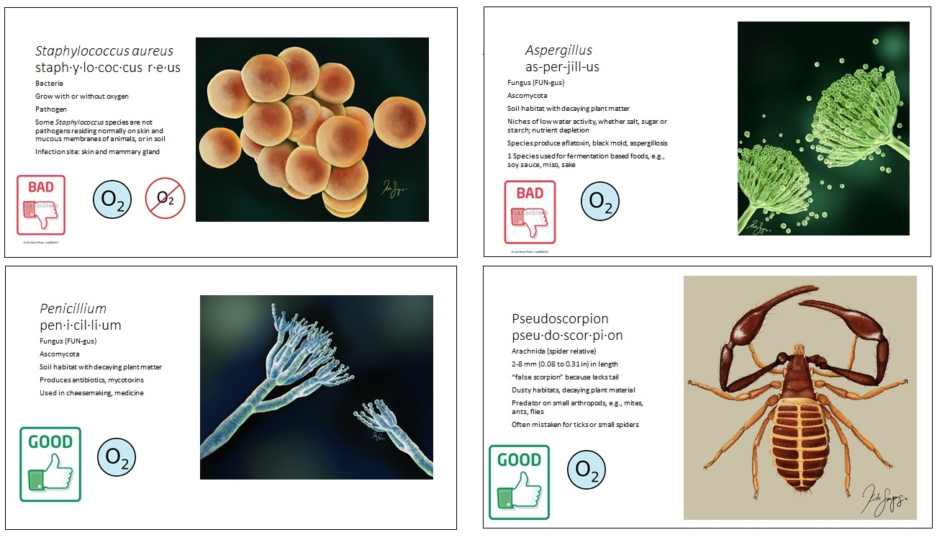

Figure 8: Examples of “Bedded pack microbial players Game cards.” Images created by artist Katie Sayers for use in communicating the unseen diversity in dairy cattle bedding.